MOD008366 Element010 - Introduction to Data Sciences and Programming September 2022 Coursework Assessment

Assessment Format:
Mode of Submission: | Canvas: Online submission via Canvas  We would suggest instead that submission is made on a browser from a computer or mobile device.  It is not recommended that you submit your assignment or take a quiz on a cellular or satellite connection. This is because loss of internet connection during assessment is most commonly associated with these services, although we understand that sometimes this is the only option. Wherever possible, we would recommend that assessments are submitted or undertaken on WiFi or hardwired (ethernet) connections.  Large files are best submitted on a hardwired internet connection (i.e., not WiFi).
Weighting: | This assessment is worth 100% of the Module mark
Assessment Level: | 4
Element Learning Outcomes: | 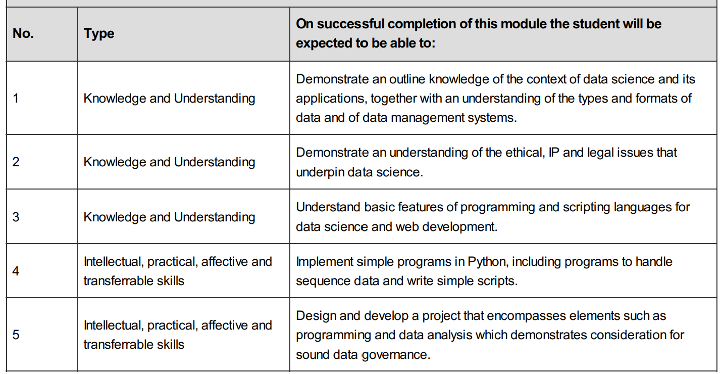
Marking Approach: | Fine-graded
Feedback Release Date: | N/A

Summary

There are two components to this assessment. All components and tasks need to be attempted to get a passing grade. All files (including all the file formats - .ipynb, . csv, .doc, . html, .pdf, etc) from the component1 should be compressed into a “.zip” file, to be submitted in through

Canvas. The component2 can be submitted as doc or pdf file on Canvas.

- Component-010/1 relates to the data analysis and web development on a selected dataset, preferably from the student’s workplace. This component submission should include the python code for data analysis as “.ipynb” file(s) with outputs displayed from your run. The submission should also include html or CSS files relating to the Web page developed to report the output of this data analysis. The webpages should include any accompanying file (like, separate CSS style sheets if preferred!). Please note any mode of CSS styling is accepted and need not be an external CSS style sheet. Please find detailed information below. The file name for the component1 submission should be “SSID-XXXXXX-DataAnalysis.zip” for submission. Replace XXXXXX in the filename with your student ID. [60 points]

- Component-010/2s relates to detailed reporting of the data analysis task above. Presenting dataset details and analysis report as a document (doc or pdf file). Details are presented below. Submit a complete report(~3000 words) through Canvas. The filename for the report should be “SSID-XXXXXX-DataReport.doc” or SSID-XXXXXX-DataReport.pdf”. Replace XXXXXX in the filename with your student ID. [40 points]

Detailed Description

- Component 010/1: “.zip” file submission including - Dataset Analysis – .ipynb file and Web Page creation – .html (+ .css) files. The file name for the component1 submission should be “SSID-XXXXXX-DataAnalysis.zip” for submission. Replace XXXXXX in the filename with your student ID. [60 points]

Select a dataset from your workplace*. Try to find a relevant descent size dataset with variety and volume. It would be preferable to have a dataset that needs clean-up as well.

This component has 3 major tasks to achieve:

Component 010/1 - Task1:

Write Python code for data pre-processing and analysis. Use Jupyter notebooks as IDE for your python code displaying the output of the code in the notebook itself. Submit the main code with the outputs displayed in and as “.ipynb” file submitted to Canvas. Remember to include visualisations. The code must be working set of executable commands (include sample data if needed!).

Please create webpages (simple HTML+ CSS style sheets) for the two further tasks in this component as mentioned below.

*Discuss with your tutor if you are struggling to find a dataset by week 5.

Component 010/1 - Task 2:

Prepare an HTML + CSS webpage (similar to a blog post) as a report for your dataset analysis. Make the webpage aesthetically pleasing with CSS style rules. Print all the graphs and visualizations generated by the Jupyter Notebook above on to this webpage. Limit the text but, keep the page comprehensive. It is not mandatory to use external style sheets and marking will not be based on this criterion. But, it is desirable to use at least one or more different CSS selector types to demonstrate the knowledge in CSS style usage

Component 010/1 - Task 3:

Create a webpage with HTML/CSS to collect some feedback on your web report from the user community. Use different inputs like text boxes, dropdowns and radio buttons. This assignment does not require you to store this information. Just creating a data entry feedback html webpage will suffice. Remember the styling so that it is easy for the users to enter information. The webpage as HTML, CSS and any related code can be submitted.

Combine the python code and html pages into a single archive “.zip” file for submission. Please note the filename should be as mentioned above SSID-XXXXXX-DataAnalysis.zip and needs to be only in zip format not tar or rar or any other format.

- Component 010/2: Data Analysis report for individual datasets - doc/pdf file submissions. Submit a complete report(~3000 words) through Canvas. The filename for the report should be “SSID-XXXXXX-DataReport.doc” or SSID-XXXXXX-DataReport.pdf”. Replace XXXXXX in the filename with your student ID. [40 points]

Please create individual reports (~3000 words) of data analysis on the dataset of your choice identified from your work. Visualisations need to be present in the report. Present the details of the data set explaining what it contains, features, what problems can this address with some visualisations and analysis of the data set. Need to use the visualizations generated yourself through the Python code. Mention some privacy, governance and ethics related concerns that should be taken care of for this dataset.

Recommended format of the report is:

- Introduction, background and description of the problem at hand. Add literature survey on earlier approaches taken to the problem and the approaches used in this work.

- Explain data analysis and data pre-processing approaches in detail. Explaining why each approach was taken with analysis results.
- Legal, ethical, privacy concerns with this data. What care needs to be taken while handling this data?
- Explain the code you have written for data analysis. Critically analysing why each approach was chosen.
- Explain in detail the conclusions, result and scope for future improvements.

*Discuss with your tutor if you are struggling to find a dataset by week 5.

- Provide relevant references in your report. ( ARU Harvard style) - https://library.aru.ac.uk/referencing/files/QuickHarvardGuide2019.pdf

Marking Scheme

Component 010/1 – Task1 - Python code (30%)

Data Set Analysis Visualisations Correctness & Comments on the Out of

(0 .. 10pts) (0 .. 5pts) Creativity (0 .. 5pts) code (0 .. 10pts) 30

Component 010/1 - Task2 – Web Page (15%)

HTML/CSS Clarity in Reporting Visualisations Aesthetics of Creativity Out of

Knowledge (0 … 3pts) (0 .. 3pts) page (0 .. 2pts) (0 .. 2pts) 15
(0 .. 5pts)

Component 010/1 – Task3 – Web Page (15%)

CSS Knowledge HTML Knowledge Aesthetics Creativity Out of

(0 .. 5pts) (0 .. 5pts) (0 .. 2pts) (0 .. 3pts) 15

Component 010/2 (40%)
Background | Data | Critical Analysis | Legal | Results & | Refere | Out
& Literature | Processing | & Creative | & | Future | nces | of
Survey | Approach | thinking for | ethical | Work | (0…5) | 40
(0…5) | (0 … 10) | Approach | details | (0…5)
 |  | (0 … 10) | (0…5)
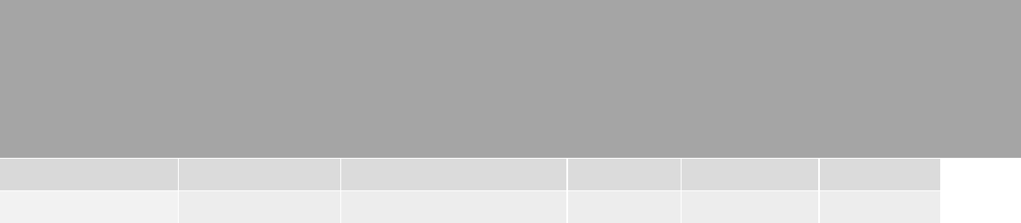

Grade Boundaries

0..29 Fail
30..39 Qualifying fail
40..49 3rdclass
50..59 lower second class
60..69 upper second class
70..100 first class

Important Notes:

Your submission will not be accepted if you do not comply with the following rules:

- Make sure you submit both parts as separate components on Canvas.
- Component 1 will accept only one “.zip” files.
- Component 2 will accept only one “.doc” or “.pdf” file.
- The file names for submission should be as recommended above in each component. If you submit with a different name, your submission won’t be accepted.

*Discuss with your tutor if you are struggling to find a dataset by week 5.

- The titles for submission should be your “SSID-XXXXXX” where XXXXXX is replaced with your student ID.

- If your complete code with the modified data directories is over the (100MB) limitation of upload, please create a “git” repo for the complete standalone project and share that link as well in the basic notebook submitted and give tutor access to it. Remember even when sharing a git repo, you must submit the basic code files in Canvas for marking.

*Discuss with your tutor if you are struggling to find a dataset by week 5.

